Sql quesries practice on Olympics dataset:-

Q1) how many olympics games have been held?

**query:-**

select count(distinct Games) as 'total_olympic_games' from athlete_events

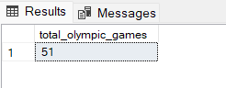

Q2) List down all Olympics games held so far?

Query:- select distinct Games, Year, Season, City from athlete_events

order by year

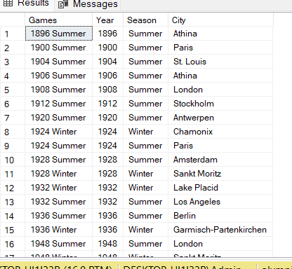

Q3) mention the total number of nations who participated in Olympics game?

Query:-

with all_countries as

(select ae.Games, nr.region

from athlete_events ae

join noc_regions nr ON nr.noc = ae.noc

group by games, nr.region)

select Games, count(1) as total_countries from all_countries

group by Games

order by Games

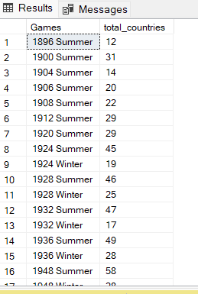

Q4) which year saw the highest and lowest number of countries participating in Olympics?

Query:- with all_countries as

(select ae.Games, nr.region

from athlete_events ae

join noc_regions nr ON nr.noc = ae.noc

group by games, nr.region),

tot_countries as

(select games, count(1) as tot_countries

from all_countries

group by games)

select distinct

concat(first_value(games) over(order by tot_countries)

, ' - '

, first_value(tot_countries) over(order by tot_countries)) as Lowest_Countries,

concat(first_value(games) over(order by tot_countries desc)

, ' - '

, first_value(tot_countries) over(order by tot_countries desc)) as Highest_Countries

from tot_countries

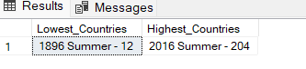

Q5) which nation has participated in all Olympic games?

Query:-

with tot_games as

(select count(distinct games) as total_games

from athlete_events),

countries as

(select games, nr.region as country

from athlete_events ae

join noc_regions nr ON nr.noc=ae.noc

group by games, nr.region),

countries_participated as

(select country, count(1) as total_participated_games

from countries

group by country)

select cp.*

from countries_participated cp

join tot_games tg on tg.total_games = cp.total_participated_games

order by 1;

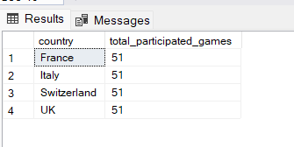

Q6) identify the sport which was played in all summer Olympics.

Query:-

with t1 as

(select count(distinct games) as total_games

from athlete_events where season = 'Summer'),

t2 as

(select distinct games, sport

from athlete_events where season = 'Summer'),

t3 as

(select sport, count(1) as no_of_games

from t2

group by sport)

select * from t3 join t1 on t3.no_of_games=t1.total_games

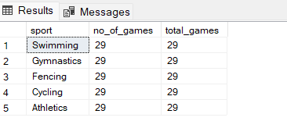

Q7) which sport were played only once in olympics?

Query:-

with t1 as (select distinct Games,sport from athlete_events),

t2 as (select sport, count(1) as total_games from t1 group by sport)

select t2.*, t1.Games

from t2 join t1 on t1.sport=t2.sport

where t2.total_games=1

order by t1.sport

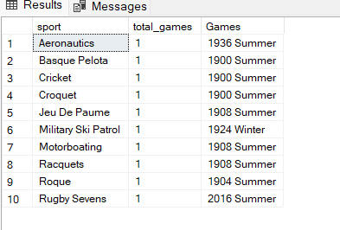

Q8) fetch the total number of sports played in each olympic games?

Query:- with t1 as

(select distinct games, sport

from athlete_events),

t2 as

(select games, count(1) as no_of_sports

from t1

group by games)

select * from t2

order by no_of_sports desc;

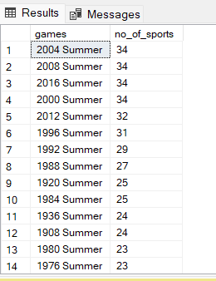

Q9)fetch oldest athletes to win a gold medal

Query:- with temp as

(select name,sex,cast(case when age = 'NA' then '0' else age end as int) as age

,team,games,city,sport, event, medal

from athlete_events),

ranking as

(select *, rank() over(order by age desc) as rnk

from temp

where medal='Gold')

select *

from ranking

where rnk =1;



Q10) find the ratio of male and female athletes participated in all olympic games.

Query:- with t1 as

(select sex, count(1) as cnt

from athlete_events

group by sex),

t2 as

(select *, row_number() over(order by cnt) as rn

from t1),

min_cnt as

(select cnt from t2 where rn = 1),

max_cnt as

(select cnt from t2 where rn = 2)

select concat('1 : ', round(cast(max_cnt.cnt as decimal)/min_cnt.cnt, 2)) as ratio

from min_cnt, max_cnt;

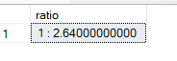

Q11) fetch top 5 athletes with gold medal in olympic games.

Query:-

with t1 as (select name, team, count(1) as total_gold_medals

from athlete_events

where medal= 'Gold'

group by name,team

),

t2 as (select t1.*,dense_rank() over(order by total_gold_medals desc) as rnk

from t1)

select name,team,total_gold_medals from t2

where rnk<=5

order by total_gold_medals desc

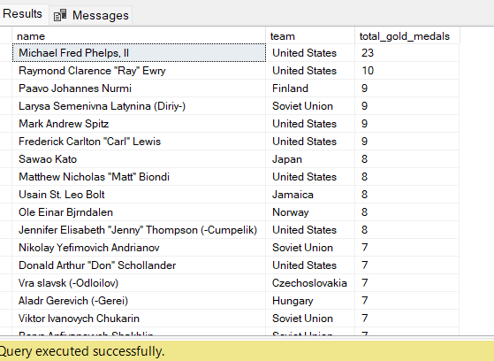

Q12) fetch the top 5 athletes who have won most medals (gold/silver/bronze)

Query:-

with t1 as (select name, team, count(1) as total_medals

from athlete_events

where medal in ('Gold', 'Silver', 'Bronze')

group by name,team

),

t2 as (select t1.*,dense_rank() over(order by total_medals desc) as rnk

from t1)

select name,team,total_medals from t2

where rnk<=5

order by total_medals desc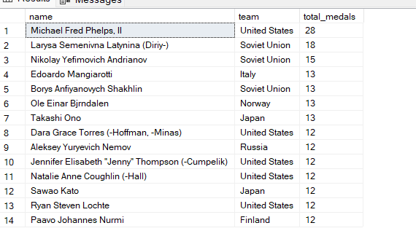

Q13) fetch the top 5 most successful countries who have won most medals.

Query:-

with t1 as

(select nr.region, count(1) as total_medals

from athlete_events ae

join noc_regions nr on nr.noc = ae.noc

where medal <> 'NA'

group by nr.region

),

t2 as

(select *, dense_rank() over(order by total_medals desc) as rnk

from t1)

select *

from t2

where rnk <= 5

order by total_medals desc;

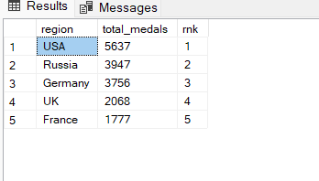

Q14)list down total gold,bronze.silver won by each country.

Query:-

with t1 as (select nr.region as country, count(1) as total_gold_medals from athlete_events ae join noc_regions nr on nr.noc = ae.noc

where medal='Gold'

group by nr.region),

t2 as (select nr.region as country, count(1) as total_silver_medals from athlete_events ae join noc_regions nr on nr.noc = ae.noc

where medal='Silver'

group by nr.region),

t3 as (select nr.region as country, count(1) as total_bronze_medals from athlete_events ae join noc_regions nr on nr.noc = ae.noc

where medal='Bronze'

group by nr.region),

t4 as (select t1.*,t2.total_silver_medals, total_bronze_medals from t1 join t2 on t1.country=t2.country join t3 on t3.country = t1.country)

select * from t4

order by total_gold_medals desc, total_silver_medals desc, total_bronze_medals desc

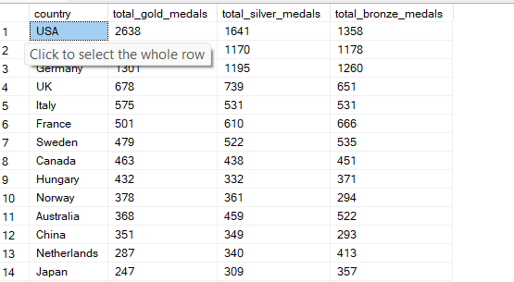

Q15) list down total gold,silver,bronze medals won by each country corresponding to each games.

Query:-

with t1 as (select nr.region as country, ae.Games, count(1) as total_gold_medals from athlete_events ae join noc_regions nr on nr.noc = ae.noc

where medal='Gold'

group by nr.region, ae.Games),

t2 as (select nr.region as country, ae.Games, count(1) as total_silver_medals from athlete_events ae join noc_regions nr on nr.noc = ae.noc

where medal='Silver'

group by nr.region, ae.Games),

t3 as (select nr.region as country, ae.Games, count(1) as total_bronze_medals from athlete_events ae join noc_regions nr on nr.noc = ae.noc

where medal='Bronze'

group by nr.region, ae.Games)

select t1.*, t2.total_silver_medals, total_bronze_medals from t1 join t2 on (t1.country=t2.country) AND (t1.Games=t2.Games) join t3 on (t1.country=t3.country) AND (t1.Games=t3.Games)

order by t1.Games,t1.total_gold_medals desc, t2.total_silver_medals desc, t3.total_bronze_medals desc

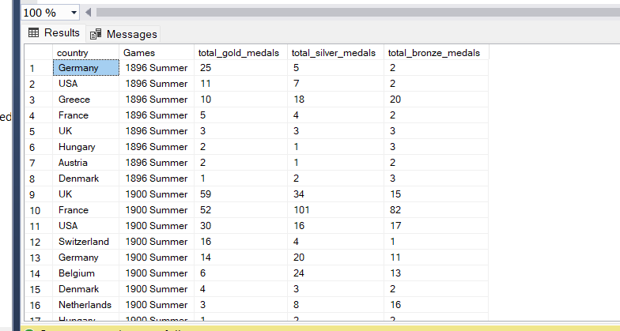

Q16) which country won most gold, most silver, most bronze in each olympics game.

Query:-

with t1 as (select nr.region as country, ae.Games, count(1) as total_gold_medals from athlete_events ae join noc_regions nr on nr.noc = ae.noc

where medal='Gold'

group by nr.region, ae.Games),

t2 as (select distinct games, concat(first_value(country)

over(partition by games order by total_gold_medals desc),'-',first_value(total_gold_medals) over(partition by games order by total_gold_medals desc))

as max_gold from t1),

t3 as (select nr.region as country, ae.Games, count(1) as total_silver_medals from athlete_events ae join noc_regions nr on nr.noc = ae.noc

where medal='Silver'

group by nr.region, ae.Games),

t4 as (select distinct games, concat(first_value(country)

over(partition by games order by total_silver_medals desc),'-',first_value(total_silver_medals) over(partition by games order by total_silver_medals desc))

as max_silver from t3),

t5 as (select nr.region as country, ae.Games, count(1) as total_bronze_medals from athlete_events ae join noc_regions nr on nr.noc = ae.noc

where medal='Bronze'

group by nr.region, ae.Games),

t6 as (select distinct games, concat(first_value(country)

over(partition by games order by total_bronze_medals desc),'-',first_value(total_bronze_medals) over(partition by games order by total_bronze_medals desc))

as max_bronze from t5)

select t2.*,max_silver,max_bronze from t2 join t4 on t2.Games = t4.Games join t6 on t6.Games= t2.Games

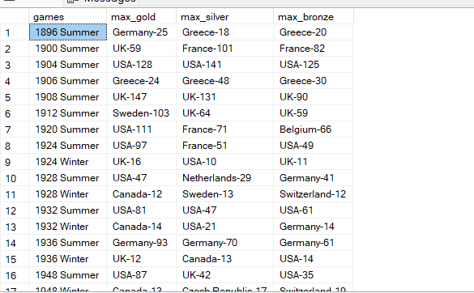

Q17)identify which country won most gold, most silver, most bronze and most medals in olympic games.

Query:-

with t1 as (select nr.region as country, ae.Games, count(1) as total_gold_medals from athlete_events ae join noc_regions nr on nr.noc = ae.noc

where medal='Gold'

group by nr.region, ae.Games),

t2 as (select distinct games, concat(first_value(country)

over(partition by games order by total_gold_medals desc),'-',first_value(total_gold_medals) over(partition by games order by total_gold_medals desc))

as max_gold from t1),

t3 as (select nr.region as country, ae.Games, count(1) as total_silver_medals from athlete_events ae join noc_regions nr on nr.noc = ae.noc

where medal='Silver'

group by nr.region, ae.Games),

t4 as (select distinct games, concat(first_value(country)

over(partition by games order by total_silver_medals desc),'-',first_value(total_silver_medals) over(partition by games order by total_silver_medals desc))

as max_silver from t3),

t5 as (select nr.region as country, ae.Games, count(1) as total_bronze_medals from athlete_events ae join noc_regions nr on nr.noc = ae.noc

where medal='Bronze'

group by nr.region, ae.Games),

t6 as (select distinct games, concat(first_value(country)

over(partition by games order by total_bronze_medals desc),'-',first_value(total_bronze_medals) over(partition by games order by total_bronze_medals desc))

as max_bronze from t5),

t7 as (select nr.region as country, ae.Games, count(1) as total_medals from athlete_events ae join noc_regions nr on nr.noc = ae.noc

where medal <> 'NA'

group by nr.region, ae.Games),

t8 as (select distinct games, concat(first_value(country)

over(partition by games order by total_medals desc),'-',first_value(total_medals) over(partition by games order by total_medals desc))

as max_medals from t7)

select t2.*,max_silver,max_bronze,max_medals from t2 join t4 on t2.Games = t4.Games join t6 on t6.Games= t2.Games join t8 on t8.games=t2.games

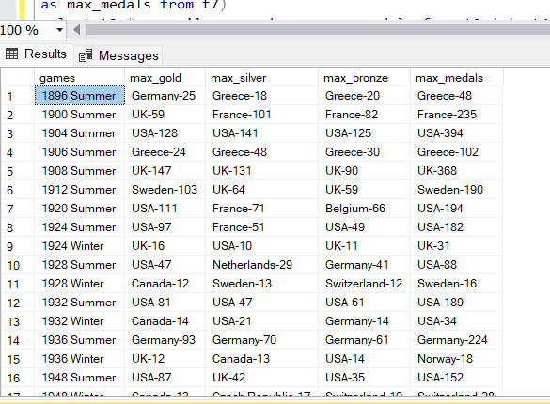

Q18)which country have never won gold medal but have won silver or bronze medal

Query:-

select nr.region as country, count(case when ae.medal='gold' then 1 end) as gold_medals, count(case when ae.medal='bronze' then 1 end) as bronze_medals, count(case when ae.medal='silver' then 1 end) as silver_medals from athlete_events ae join noc_regions nr on ae.noc=nr.noc

where medal <> 'gold' and (medal='silver' or medal='bronze')

group by nr.region,ae.medal

order by country

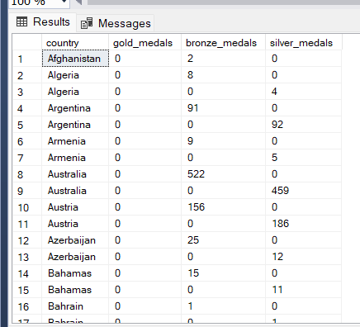

Q19) in which sport event india has won highest medals

Query:-

select top 1 ae.Sport, count(1) as total_medals

from athlete_events ae join noc_regions nr on ae.noc=nr.noc

where nr.region = 'India'

group by ae.Sport

order by total_medals desc

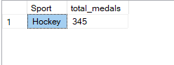

Q20)break down all olympic games where india won medal for hockey and how many medals in each olympic games

Query:-

select ae.Team, ae.sport, ae.Games, count(1) as total_medals from athlete_events ae join noc_regions nr

on ae.noc=nr.noc

where nr.region='India' and ae.Sport='Hockey'

group by ae.Games,ae.Team,ae.Sport

order by total_medals desc

